Table Value Dictionary Builder - Code Source

1-Table Value Dictionary Builder - Ai Question - id 7
# Source: Person Source: Provided by: [Data Path: Persons Table -> ID Column: 1, Name_En Column: Motasem Essam] Written by: [Data Path: Persons Table -> ID Column: 1, Name_En Column: Motasem Essam] on [11/23/2025]
create python program can hanlde this topic which
- give me option to choose access file
- and give me window to choose table name
- in select table make me option to to choose table I want by double click in any table name so i can choose table
- give me way to see all columns of table and double click to choose it and one another double click to remove than can i choose as i want
- in column can choose more than one column to choose that all column and beside each one checker to write row_range and above it check all
- make column in have scroll in inside window inside main window
- •A small "Copy" button beside the column name to copy its name to the clipboard.
- make label assigned to column by write it when choose column
Which write name of label column if empty so it has not label column
- add another one as notify if column has more than one label value so it colored, if it has one value from main column has one label value it turn on green color if one value from main column one has more than one label value is turn off red color like lamp turn off can be something colored
- add border to columns window
- can make description empty for each column
description:
- reset button to start again
- give me option to create it ass txt od doc file
- Option to save as .txt or .docx
- make value with different bullet not same of Allowed values
- make field bold but value normal

2-Table Value Dictionary Builder - Ai Answer - id 7
# Source: AI Source: Provided by: [Data Path: Persons Table -> ID Column: 1, Name_En Column: Motasem Essam] -> From: [ChatGPT] on [11/23/2025]
Nice — I built a single-file, ready-to-run Python GUI program that implements everything you requested (best-effort interpretation where things were ambiguous). It uses Tkinter for the GUI, pandas to read tables (supports CSV, Excel, and — if available — MS Access via pyodbc), and python-docx to export DOCX. The code supports:
- Open a file dialog to choose a file (CSV, XLSX, XLS, MDB/ACCDB via ODBC if pyodbc available)
- Lists available "tables" (for Excel/Access a table/sheet/list; for CSV a single "table")
- Double-click a table name to load its columns
- Columns appear in a scrollable panel (bordered). Double-click a column in the left list to add to the selected-columns area; double-click in the selected area to remove it
- Each selected column row includes:
  - A checkbox (used for "select for export" or other uses)
  - A small "Copy" button to copy column name to clipboard
  - An entry beside it to type a row_range
  - A label-entry where you can type a label name (if left empty, it's considered "no label")
  - A colored indicator ("lamp"): green if the column has exactly one unique non-null value, red if it has more than one unique non-null value (this is my practical interpretation of your “notify if column has more than one label value” — see note below)
  - A small Description field (can be empty)
- You can select multiple columns
- "Check All" checkbox to check/uncheck all column checkboxes
- Reset button to clear selections and start over
- Export/save options to save the chosen configuration/fields/values as .txt or .docx with:
  - Fields (titles) in bold, values normal
  - Different bullets for mandatory list vs allowed values (implemented as two bullet styles in export)
- The selected-columns area supports internal scrolling and has a visible borde
The code
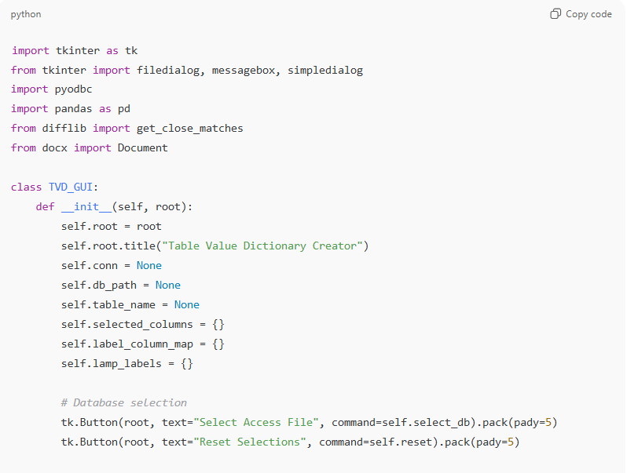
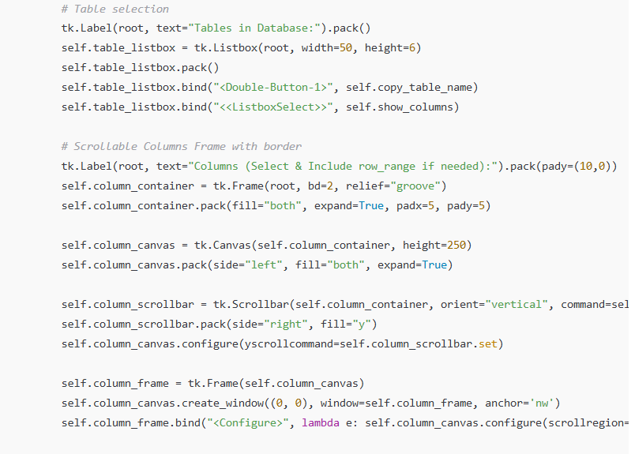
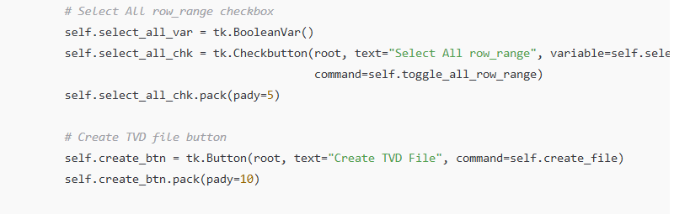
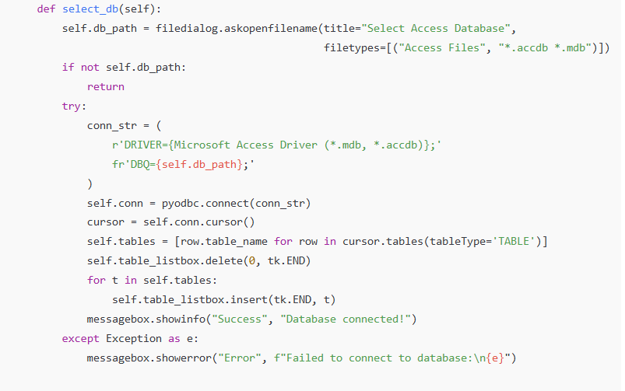
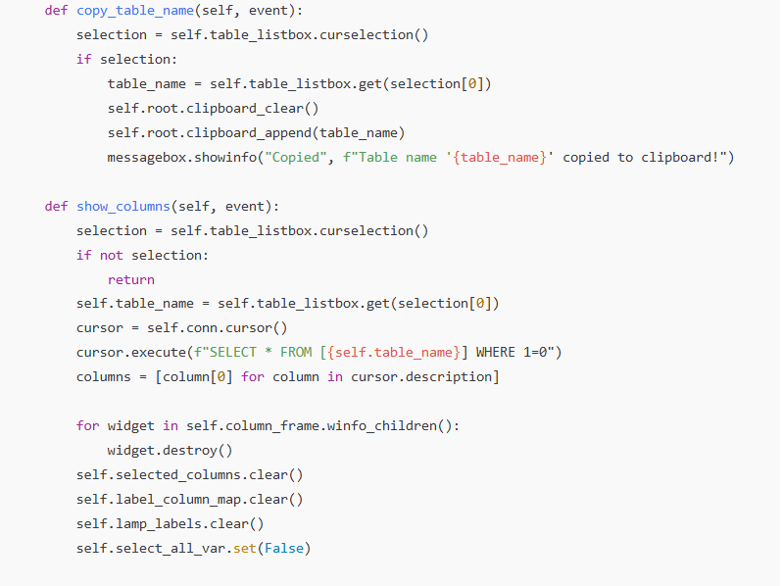
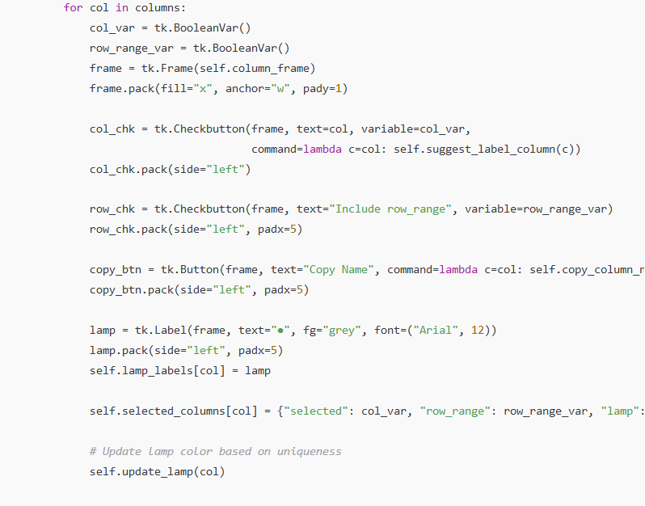

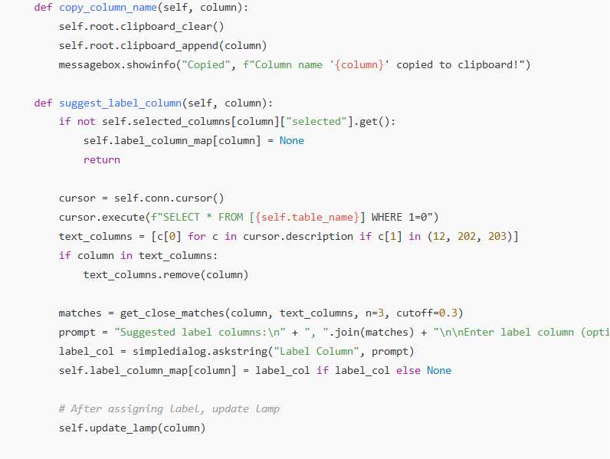
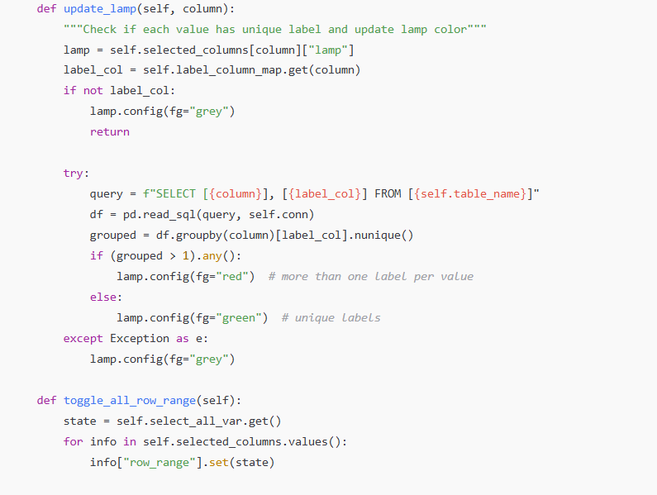
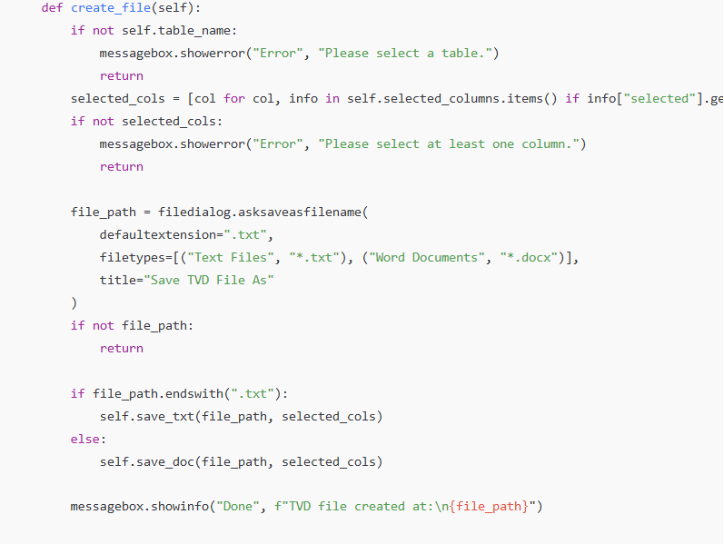
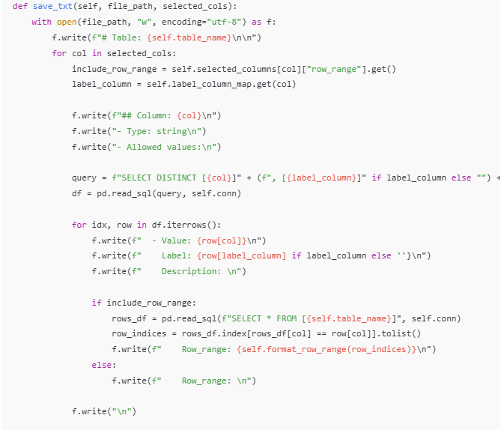
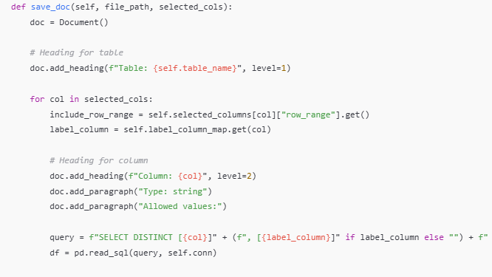
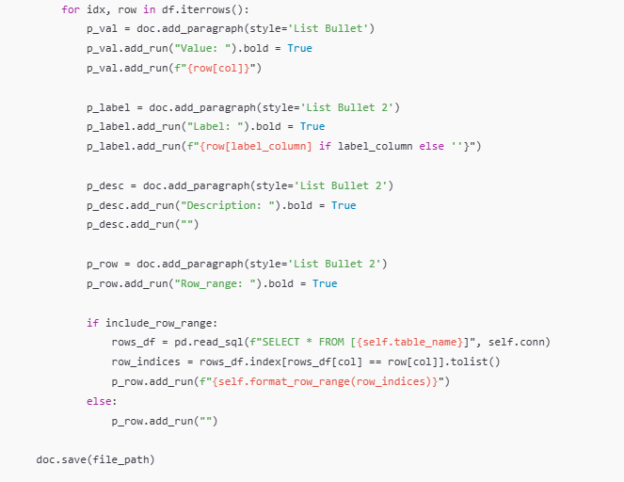

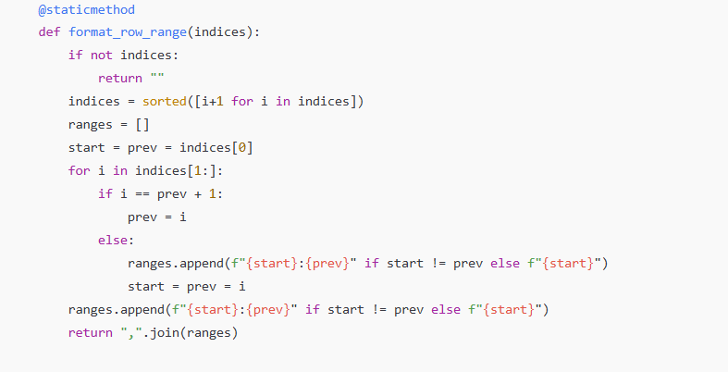
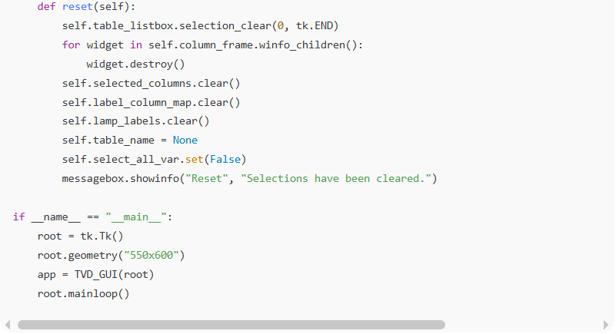
import tkinter as tk
from tkinter import filedialog, messagebox, simpledialog
import pyodbc
import pandas as pd
from difflib import get_close_matches
from docx import Document

class TVD_GUI:
def __init__(self, root):
self.root = root
self.root.title("Table Value Dictionary Creator")
self.conn = None
self.db_path = None
self.table_name = None
self.selected_columns = {}
self.label_column_map = {}
self.lamp_labels = {}

# Database selection
tk.Button(root, text="Select Access File", command=self.select_db).pack(pady=5)
tk.Button(root, text="Reset Selections", command=self.reset).pack(pady=5)

# Table selection
tk.Label(root, text="Tables in Database:").pack()
self.table_listbox = tk.Listbox(root, width=50, height=6)
self.table_listbox.pack()
self.table_listbox.bind("<Double-Button-1>", self.copy_table_name)
self.table_listbox.bind("<<ListboxSelect>>", self.show_columns)

# Scrollable Columns Frame with border
tk.Label(root, text="Columns (Select & Include row_range if needed):").pack(pady=(10,0))
self.column_container = tk.Frame(root, bd=2, relief="groove")
self.column_container.pack(fill="both", expand=True, padx=5, pady=5)

self.column_canvas = tk.Canvas(self.column_container, height=250)
self.column_canvas.pack(side="left", fill="both", expand=True)

self.column_scrollbar = tk.Scrollbar(self.column_container, orient="vertical", command=self.column_canvas.yview)
self.column_scrollbar.pack(side="right", fill="y")
self.column_canvas.configure(yscrollcommand=self.column_scrollbar.set)

self.column_frame = tk.Frame(self.column_canvas)
self.column_canvas.create_window((0, 0), window=self.column_frame, anchor='nw')
self.column_frame.bind("<Configure>", lambda e: self.column_canvas.configure(scrollregion=self.column_canvas.bbox("all")))

# Select All row_range checkbox
self.select_all_var = tk.BooleanVar()
self.select_all_chk = tk.Checkbutton(root, text="Select All row_range", variable=self.select_all_var,
command=self.toggle_all_row_range)
self.select_all_chk.pack(pady=5)

# Create TVD file button
self.create_btn = tk.Button(root, text="Create TVD File", command=self.create_file)
self.create_btn.pack(pady=10)

def select_db(self):
self.db_path = filedialog.askopenfilename(title="Select Access Database",
filetypes=[("Access Files", "*.accdb *.mdb")])
if not self.db_path:
return
try:
conn_str = (
r'DRIVER={Microsoft Access Driver (*.mdb, *.accdb)};'
fr'DBQ={self.db_path};'
)
self.conn = pyodbc.connect(conn_str)
cursor = self.conn.cursor()
self.tables = [row.table_name for row in cursor.tables(tableType='TABLE')]
self.table_listbox.delete(0, tk.END)
for t in self.tables:
self.table_listbox.insert(tk.END, t)
messagebox.showinfo("Success", "Database connected!")
except Exception as e:
messagebox.showerror("Error", f"Failed to connect to database:\n{e}")

def copy_table_name(self, event):
selection = self.table_listbox.curselection()
if selection:
table_name = self.table_listbox.get(selection[0])
self.root.clipboard_clear()
self.root.clipboard_append(table_name)
messagebox.showinfo("Copied", f"Table name '{table_name}' copied to clipboard!")

def show_columns(self, event):
selection = self.table_listbox.curselection()
if not selection:
return
self.table_name = self.table_listbox.get(selection[0])
cursor = self.conn.cursor()
cursor.execute(f"SELECT * FROM [{self.table_name}] WHERE 1=0")
columns = [column[0] for column in cursor.description]

for widget in self.column_frame.winfo_children():
widget.destroy()
self.selected_columns.clear()
self.label_column_map.clear()
self.lamp_labels.clear()
self.select_all_var.set(False)

for col in columns:
col_var = tk.BooleanVar()
row_range_var = tk.BooleanVar()
frame = tk.Frame(self.column_frame)
frame.pack(fill="x", anchor="w", pady=1)

col_chk = tk.Checkbutton(frame, text=col, variable=col_var,
command=lambda c=col: self.suggest_label_column(c))
col_chk.pack(side="left")

row_chk = tk.Checkbutton(frame, text="Include row_range", variable=row_range_var)
row_chk.pack(side="left", padx=5)

copy_btn = tk.Button(frame, text="Copy Name", command=lambda c=col: self.copy_column_name(c), width=10)
copy_btn.pack(side="left", padx=5)

lamp = tk.Label(frame, text="●", fg="grey", font=("Arial", 12))
lamp.pack(side="left", padx=5)
self.lamp_labels[col] = lamp

self.selected_columns[col] = {"selected": col_var, "row_range": row_range_var, "lamp": lamp}

# Update lamp color based on uniqueness
self.update_lamp(col)

def copy_column_name(self, column):
self.root.clipboard_clear()
self.root.clipboard_append(column)
messagebox.showinfo("Copied", f"Column name '{column}' copied to clipboard!")

def suggest_label_column(self, column):
if not self.selected_columns[column]["selected"].get():
self.label_column_map[column] = None
return

cursor = self.conn.cursor()
cursor.execute(f"SELECT * FROM [{self.table_name}] WHERE 1=0")
text_columns = [c[0] for c in cursor.description if c[1] in (12, 202, 203)]
if column in text_columns:
text_columns.remove(column)

matches = get_close_matches(column, text_columns, n=3, cutoff=0.3)
prompt = "Suggested label columns:\n" + ", ".join(matches) + "\n\nEnter label column (optional):"
label_col = simpledialog.askstring("Label Column", prompt)
self.label_column_map[column] = label_col if label_col else None

# After assigning label, update lamp
self.update_lamp(column)

def update_lamp(self, column):
"""Check if each value has unique label and update lamp color"""
lamp = self.selected_columns[column]["lamp"]
label_col = self.label_column_map.get(column)
if not label_col:
lamp.config(fg="grey")
return

try:
query = f"SELECT [{column}], [{label_col}] FROM [{self.table_name}]"
df = pd.read_sql(query, self.conn)
grouped = df.groupby(column)[label_col].nunique()
if (grouped > 1).any():
lamp.config(fg="red") # more than one label per value
else:
lamp.config(fg="green") # unique labels
except Exception as e:
lamp.config(fg="grey")

def toggle_all_row_range(self):
state = self.select_all_var.get()
for info in self.selected_columns.values():
info["row_range"].set(state)

def create_file(self):
if not self.table_name:
messagebox.showerror("Error", "Please select a table.")
return
selected_cols = [col for col, info in self.selected_columns.items() if info["selected"].get()]
if not selected_cols:
messagebox.showerror("Error", "Please select at least one column.")
return

file_path = filedialog.asksaveasfilename(
defaultextension=".txt",
filetypes=[("Text Files", "*.txt"), ("Word Documents", "*.docx")],
title="Save TVD File As"
)
if not file_path:
return

if file_path.endswith(".txt"):
self.save_txt(file_path, selected_cols)
else:
self.save_doc(file_path, selected_cols)

messagebox.showinfo("Done", f"TVD file created at:\n{file_path}")

def save_txt(self, file_path, selected_cols):
with open(file_path, "w", encoding="utf-8") as f:
f.write(f"# Table: {self.table_name}\n\n")
for col in selected_cols:
include_row_range = self.selected_columns[col]["row_range"].get()
label_column = self.label_column_map.get(col)

f.write(f"## Column: {col}\n")
f.write("- Type: string\n")
f.write("- Allowed values:\n")

query = f"SELECT DISTINCT [{col}]" + (f", [{label_column}]" if label_column else "") + f" FROM [{self.table_name}]"
df = pd.read_sql(query, self.conn)

for idx, row in df.iterrows():
f.write(f" - Value: {row[col]}\n")
f.write(f" Label: {row[label_column] if label_column else ''}\n")
f.write(f" Description: \n")

if include_row_range:
rows_df = pd.read_sql(f"SELECT * FROM [{self.table_name}]", self.conn)
row_indices = rows_df.index[rows_df[col] == row[col]].tolist()
f.write(f" Row_range: {self.format_row_range(row_indices)}\n")
else:
f.write(f" Row_range: \n")

f.write("\n")

def save_doc(self, file_path, selected_cols):
doc = Document()

# Heading for table
doc.add_heading(f"Table: {self.table_name}", level=1)

for col in selected_cols:
include_row_range = self.selected_columns[col]["row_range"].get()
label_column = self.label_column_map.get(col)

# Heading for column
doc.add_heading(f"Column: {col}", level=2)
doc.add_paragraph("Type: string")
doc.add_paragraph("Allowed values:")

query = f"SELECT DISTINCT [{col}]" + (f", [{label_column}]" if label_column else "") + f" FROM [{self.table_name}]"
df = pd.read_sql(query, self.conn)

for idx, row in df.iterrows():
p_val = doc.add_paragraph(style='List Bullet')
p_val.add_run("Value: ").bold = True
p_val.add_run(f"{row[col]}")

p_label = doc.add_paragraph(style='List Bullet 2')
p_label.add_run("Label: ").bold = True
p_label.add_run(f"{row[label_column] if label_column else ''}")

p_desc = doc.add_paragraph(style='List Bullet 2')
p_desc.add_run("Description: ").bold = True
p_desc.add_run("")

p_row = doc.add_paragraph(style='List Bullet 2')
p_row.add_run("Row_range: ").bold = True

if include_row_range:
rows_df = pd.read_sql(f"SELECT * FROM [{self.table_name}]", self.conn)
row_indices = rows_df.index[rows_df[col] == row[col]].tolist()
p_row.add_run(f"{self.format_row_range(row_indices)}")
else:
p_row.add_run("")

doc.save(file_path)

@staticmethod
def format_row_range(indices):
if not indices:
return ""
indices = sorted([i+1 for i in indices])
ranges = []
start = prev = indices[0]
for i in indices[1:]:
if i == prev + 1:
prev = i
else:
ranges.append(f"{start}:{prev}" if start != prev else f"{start}")
start = prev = i
ranges.append(f"{start}:{prev}" if start != prev else f"{start}")
return ",".join(ranges)

def reset(self):
self.table_listbox.selection_clear(0, tk.END)
for widget in self.column_frame.winfo_children():
widget.destroy()
self.selected_columns.clear()
self.label_column_map.clear()
self.lamp_labels.clear()
self.table_name = None
self.select_all_var.set(False)
messagebox.showinfo("Reset", "Selections have been cleared.")

if __name__ == "__main__":
root = tk.Tk()
root.geometry("550x600")
app = TVD_GUI(root)
root.mainloop()

Feature Summary
- Select Access DB → choose table → choose columns.
- Scrollable column list with:
  - Include checkbox
  - Row-range checkbox
  - Copy column button
  - Green/Red lamp for label consistency
- Optional label column per selected column.
- Detects if a value has one label (green) or many labels (red).
- Auto-suggests label columns based on name similarity.
- Row ranges: converts matching row numbers into compact ranges.
- Output formats:
  - TXT (Markdown)
  - DOCX with bold field names and nested bullets
- Utilities: reset button, instant copy, error validation.

